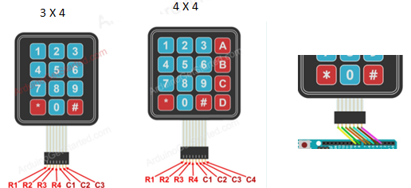

ADD LIBRARY KeyPad

Keypad 3x4

D9, D8, D7, D6, D5, D4, D3

#include <**Keypad**.h>

const int ROW_NUM = 4; //four rows

const int COLUMN_NUM = 3; //three columns

char keys[ROW_NUM][COLUMN_NUM] = {

{'1','2','3'},

{'4','5','6'},

{'7','8','9'},

{'*','0','#'}

};

byte pin_rows[ROW_NUM] = {9, 8, 7, 6}; // R1, R2, R3, R4

byte pin_column[COLUMN_NUM] = {5, 4, 3}; // C1, C2, C3

**Keypad** keypad = **Keypad**( makeKeymap(keys), pin_rows, pin_column, ROW_NUM, COLUMN_NUM );

void setup(){

**Serial**.begin(9600);

}

void loop(){

char key = keypad.getKey();

if (key){

**Serial**.println(key);

}

}

4X4

D9, D8, D7, D6, D5, D4, D3, D2

#include <**Keypad**.h>

const int ROW_NUM = 4; //four rows

const int COLUMN_NUM = 4; //four columns

char keys[ROW_NUM][COLUMN_NUM] = {

{'1','2','3', 'A'},

{'4','5','6', 'B'},

{'7','8','9', 'C'},

{'*','0','#', 'D'}

};

byte pin_rows[ROW_NUM] = {9, 8, 7, 6}; // R1, R2, R3, R4

byte pin_column[COLUMN_NUM] = {5, 4, 3, 2}; //C1, C2, C3, C4